PROJECT REPORT TEMPLATE

1. INTRODUCTION

The project aims to enhance the innovation and entrepreneurship skills of students through various project – based learning .

PURPOSE:

we can acquire technical and professional competencies while working on real-world challenges and creating innovative solutions.

1. i) EMPATHY MAP:

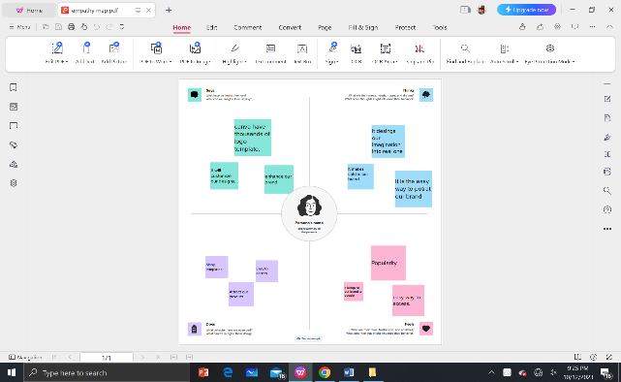

ii) BRAINSTORMING MAP:

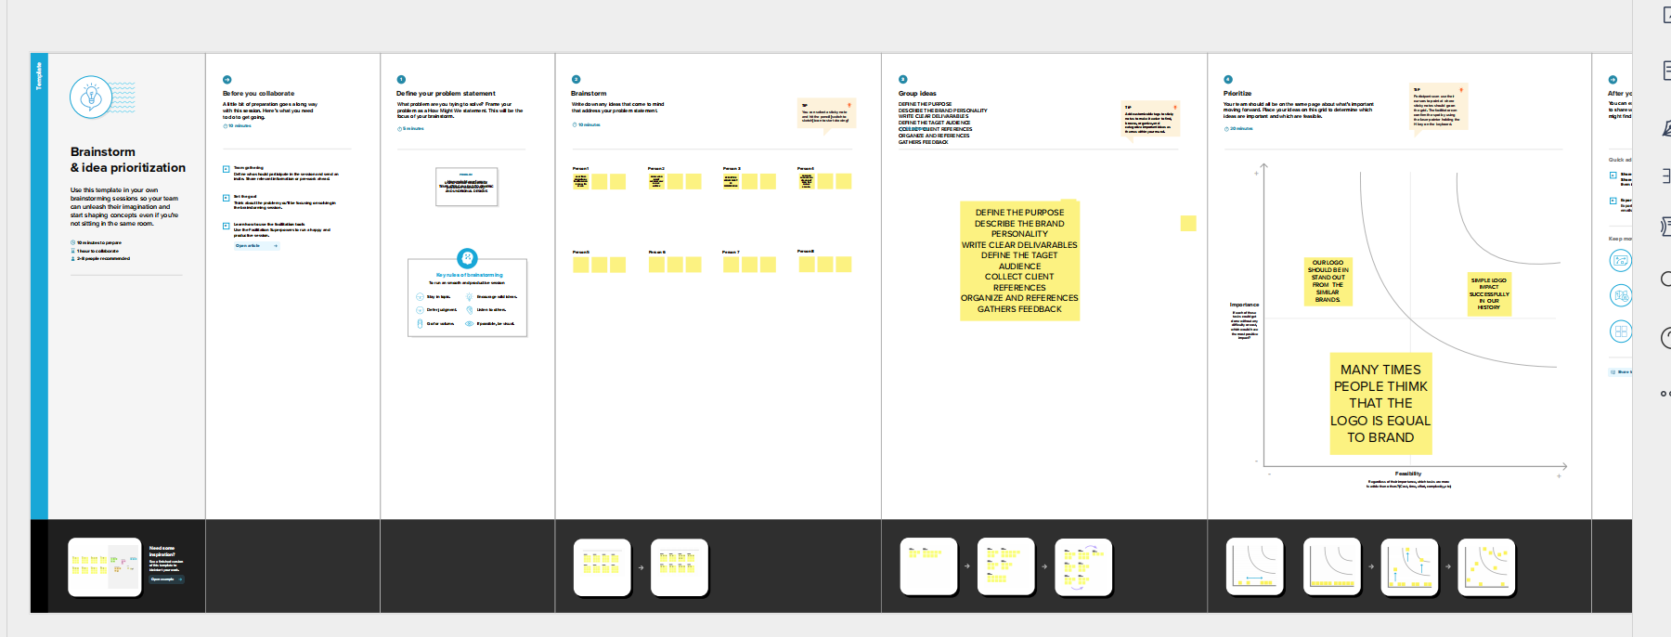

1. RESULT:



1. ADVANTAGES:

This logo can easily identifiable to all.

We can get many designs.

DISADVANTAGES:

Our designs may not reach to scholars

Everyone can use our templates.

1. APPLICATIONS:

These applications can accessible. These designs helps us to design our dreams into real .

1. CONCLUSION:

I learnt to design the logo. This features can easy to design my ideas. It can reach to all.